Shaik Sharifa Jahan

AP22110011103

1. Write a program in assembly language to take two single-digit numbers as input and

display whether they are equal or not.

org 100h

mov dx,offset msg_input1

mov ah,09h

int 21h

mov ah,01h

int 21h

mov bh,al

cmp bh,'0'

jl notdigit

cmp bh,'9'

jg notdigit

mov dx,offset msg_input2

mov ah,09h

int 21h

mov ah,01h

int 21h

mov bl,al

cmp bl,'0'

jl notdigit

cmp bl,'9'

jg notdigit

cmp bl,bh

je equal

mov dx,offset msg_output_not_equal

mov ah,09h

int 21h

jmp endprogram

equal:

mov dx,offset msg_output_equal

mov ah,09h

int 21h

jmp endprogram

notdigit:

mov dx,offset msg_error

mov ah,09h

int 21h

endprogram:

mov ah,4Ch

int 21h

msg_input1 db 'Enter integer1:$'

msg_input2 db 0ah,0dh,'Enter integer2:$'

msg_output_equal db 0ah,0dh,'The two numbers are equal$'

msg_error db 0ah,0dh,'Not a number$'

msg_output_not_equal db 0ah,0dh,'The two numbers are not equal$'

end

Output:

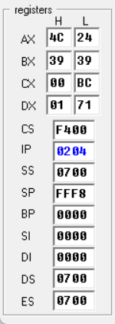

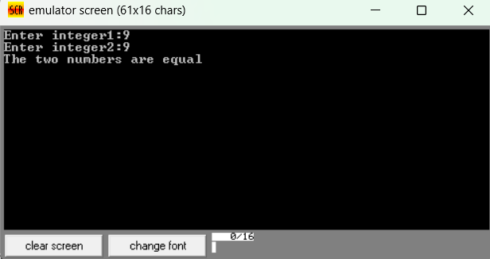

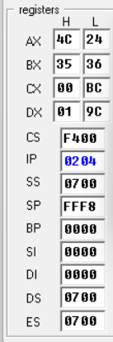

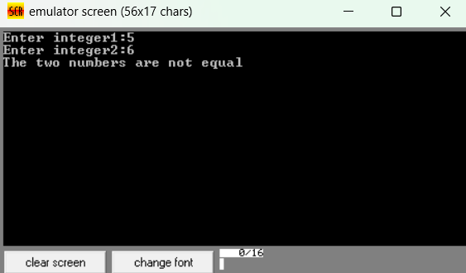

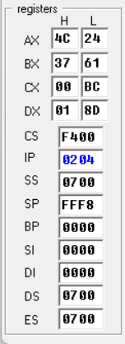

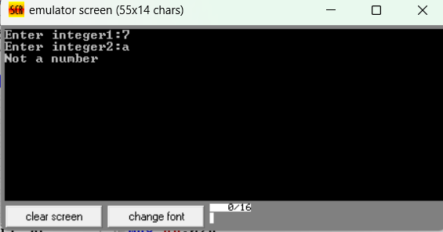

1. Write a program in assembly language to check whether a single-digit number is odd or

even.

org 100h

mov dx,offset msg_input

mov ah,09h

int 21h

mov ah,01h

int 21h

mov ah,00

mov bl,2

div bl

cmp ah,0

je equal

mov dx,offset msg_odd

mov ah,09h

int 21h

jmp endprogram

equal:

mov dx,offset msg_even

mov ah,09h

int 21h

endprogram:

mov ah,4Ch

int 21h

msg_input db 'Enter digit:$'

msg_even db 0ah,0dh,'The number is even$'

msg_odd db 0ah,0dh,'The number is odd$'

end

Output:

